Group Name:

Muhammad Izham Bin Norhamadi B032020039

Affendy Elyas bin Azhari Sharidan B032020024

Ahmad Sha Herizam Bin Tahir B032020009

# Lab 2 Introduction to Raspberry Pi

## Raspberry Pi versions

|  |  |  |  |  |  |  |  |  |
| --- | --- | --- | --- | --- | --- | --- | --- | --- |
| Family | Model | SoC | Memory | Form Factor | Ethernet | Wireless | GPIO | Released |
| Raspberry Pi | B | BCM2835 | 256 MB | Standard | Yes | No | 26-pin | Feb-12 |
| Raspberry Pi | B | BCM2835 | 512 MB | Standard | Yes | No | 26-pin | Oct-12 |
| Raspberry Pi | A | BCM2835 | 256 MB | Standard | No | No | 26-pin | 2013 |
| Raspberry Pi | B+ | BCM2835 | 512 MB | Standard | Yes | No | 40-pin | 2014 |
| Raspberry Pi | A+ | BCM2835 | 512 MB | Compact | No | No | 40-pin | 2014 |
| Raspberry Pi 2 | B | BCM2836/7 | 1 GB | Standard | Yes | No | 40-pin | 2015 |
| Raspberry Pi Zero | Zero | BCM2835 | 512 MB | Ultra-compact | No | No | 40-pin | 2015 |
| Raspberry Pi Zero | W/WH | BCM2835 | 512 MB | Ultra-compact | No | Yes | 40-pin | 2017 |
| Raspberry Pi Zero | 2 W | BCM2710A1 | 512 MB | Ultra-compact | No | Yes | 40-pin | 2021 |
| Raspberry Pi 3 | B | BCM2837A0/B0 | 1 GB | Standard | Yes | Yes | 40-pin | 2016 |
| Raspberry Pi 3 | A+ | BCM2837B0 | 512 MB | Compact | No | Yes (dual band) | 40-pin | 2018 |
| Raspberry Pi 3 | B+ | BCM2837B0 | 1 GB | Standard | Yes (Gigabit Ethernet) | Yes (dual band) | 40-pin | 2018 |
| Raspberry Pi 4 | B | BCM2711 | 1 GB | Standard | Yes (Gigabit Ethernet) | Yes (dual band) | 40-pin | 2019 |
| Raspberry Pi 4 | B | BCM2711 | 2 GB | Standard | Yes (Gigabit Ethernet) | Yes (dual band) | 40-pin | 2019 |
| Raspberry Pi 4 | B | BCM2711 | 4 GB | Standard | Yes (Gigabit Ethernet) | Yes (dual band) | 40-pin | 2019 |
| Raspberry Pi 4 | B | BCM2711 | 8 GB | Standard | Yes (Gigabit Ethernet) | Yes (dual band) | 40-pin | 2020 |
| Raspberry Pi 4 | 400 | BCM2711 | 4 GB | Keyboard | Yes (Gigabit Ethernet) | Yes (dual band) | 40-pin | 2020 |
| Raspberry Pi Pico | N/A | RP2040 | 264 KB | Pico (21 mm × 51 mm) | No | No | 40-pin | 2021 |
| Raspberry Pi Pico | W | RP2040 | 264 KB | Pico (21 mm × 51 mm) | No | Yes (2.4 GHz band) | 40-pin | 2022 |

## Assemble Raspberry Pi as a minicomputer

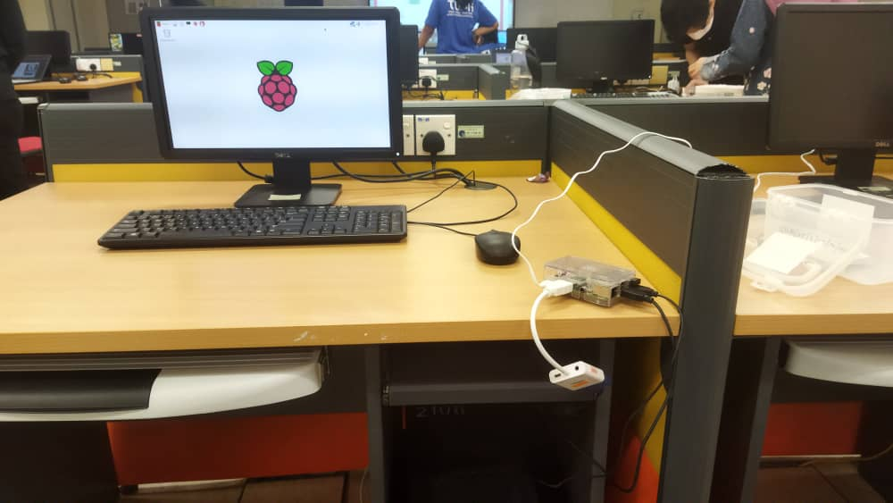

1. Power outlets connect to nearest power supply to make sure Raspberry pi can be turn on,
2. Using HDMI cable to connect Raspberry pi to screen monitor.
3. Using USB cable to connect Raspberry pi to mouse and keyboard.
4. Using Ethernet cable to connect Raspberry pi to LAN network.
5. SD card is used to install OS and store data.

## Write a comprehensive report about the modules installed in the Raspberry Pi

Python 3

There are preinstalled python 3 module in the Raspberry Pi. Python is a popular high level programming language commonly used in the Raspberry Pi. This programming language can easily be recognized by its design philosophy, which makes heavy use of indentation. It is easily readable language because its formatting is visually clean and frequently replaces punctuation with English keywords. We can create Python programs by writing the code in a text editor such as nano, vim, emacs, Midnight Commander, Leafpad and then run it from the terminal with the command. One of the IDE that can be used in Raspberry Pi to code and run Python is Thonny IDE.

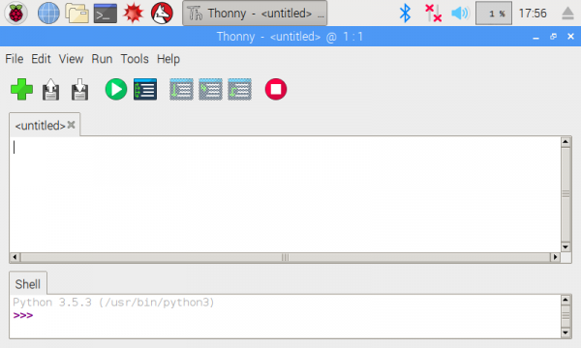

Thonny IDE

Node-RED

Node-RED is a flow-based visual programming tool that was initially developed by IBM to connect and wire together hardware components, APIs, and online services such as Internet of Things. An online flow editor powered by Node-RED is available for developing JavaScript functions. The runtime was built upon Node.js which is known for being lightweight that makes it ideal to run at the edge of the network on low-cost hardware such as the Raspberry Pi as well as in the cloud. The flows created in Node-RED are stored using JSON and can be imported and exported easily.

**Creating a flow with Node-RED**

It is easy and intuitive to work on Node-RED using its web-based flow editor. To create a flow, drag and place a node from the palette bar on the left, placing it on the flow board and connect those nodes. The nodes can be categorized into Messages, Flow control, Error handling, HTTP endpoints, HTTP requests, and MQTT (Standard for IoT Messaging).

## Discuss how Raspberry Pi can be categorized as an IoT device

Raspberry Pi has a strong CPU paired with Wireless LAN and Bluetooth 4.1 come with compact size makes it perfect to be an IoT device plus it can connect multiple sensors simultaneously especially having a connector 40-pin GPIO that can connect to external sensors by using jumper wires. Motion sensors such as PIR motion sensor can connect to Raspberry Pi’s GPIO to detect motion. Having a small and compact size is very helpful in projects where space is crucial such as wearable IoT devices which are popular nowadays in this modern era.